Single Sign-On:

1. Go to IAM Identity center

## Enable IAM Identity Center

1. Click Continue   
   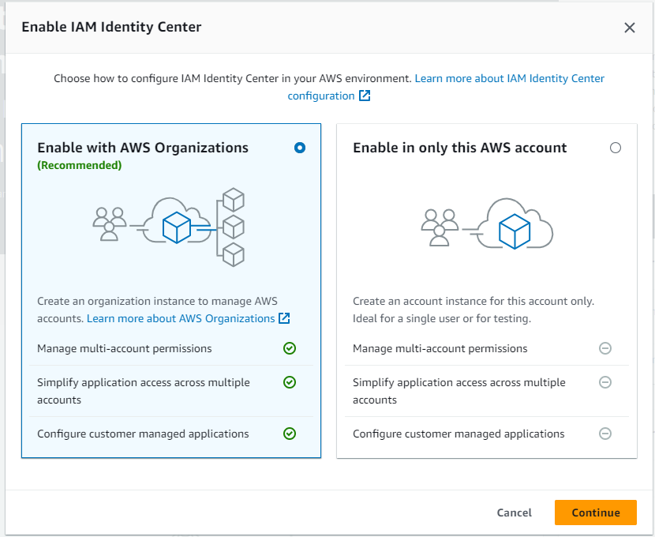
2. 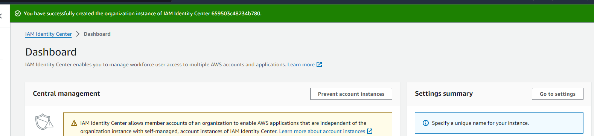
3. In Multi-account permissions , go to AWS account  
   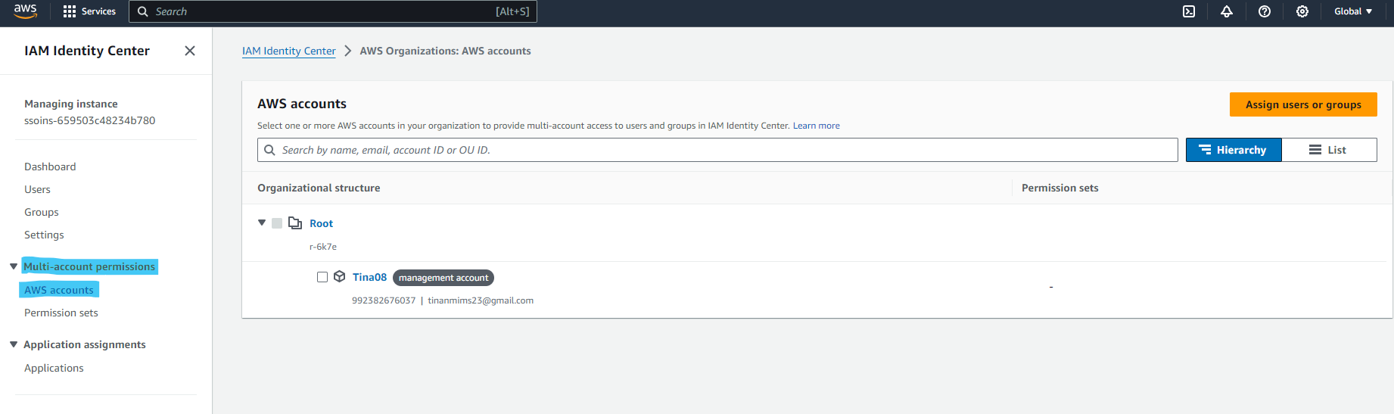
4. 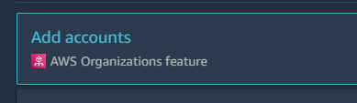
5. Create a new account  
     
   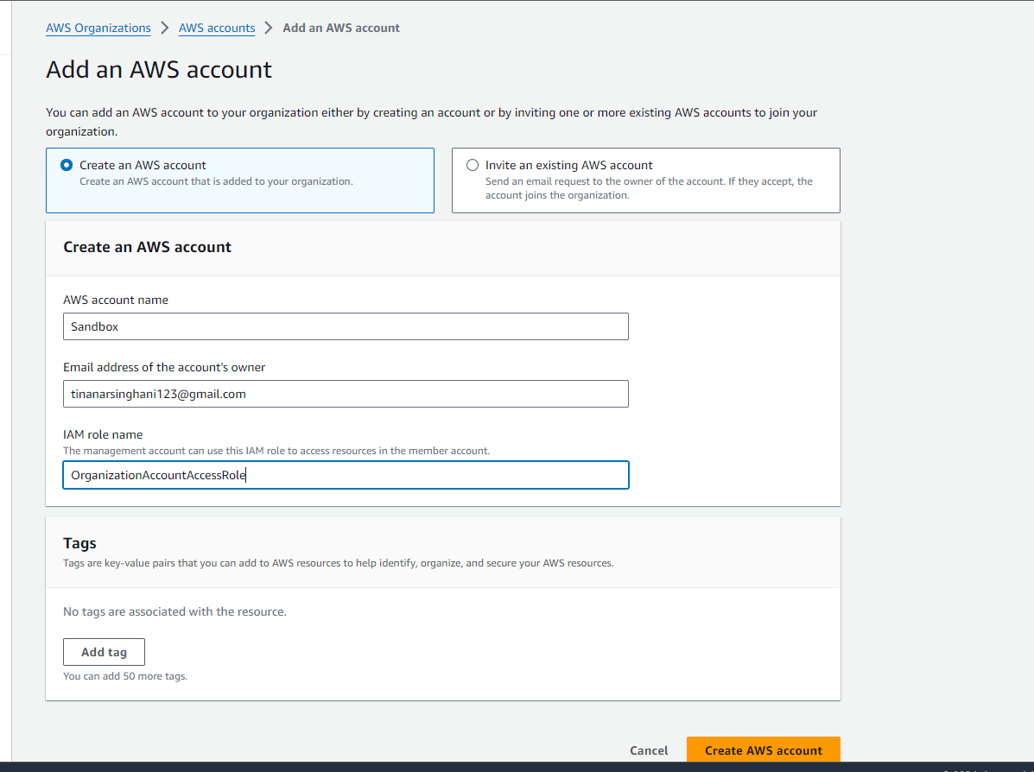
6. Edit AWS access portal url to your unique domain  
     
   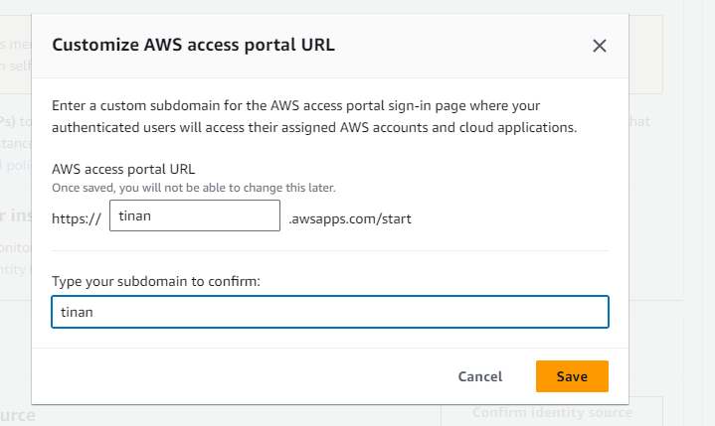  
   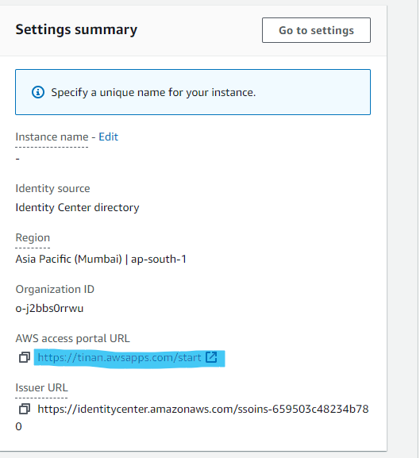
7. Change your region domain to Mumbai
8. Create a group for users  
   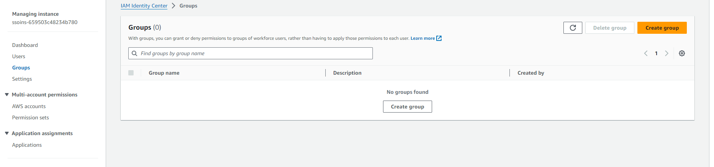
9. Create a New user and provide same email as you provided to new account in step 7  
     
   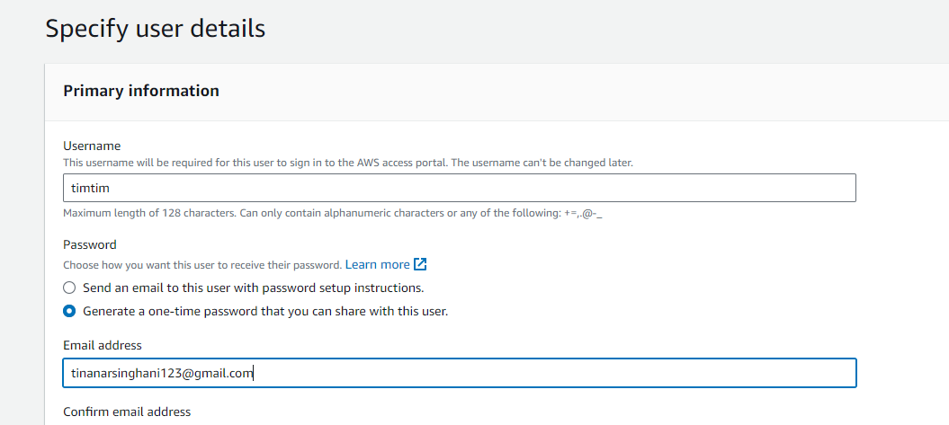
10. Add User to the group you created  
      
    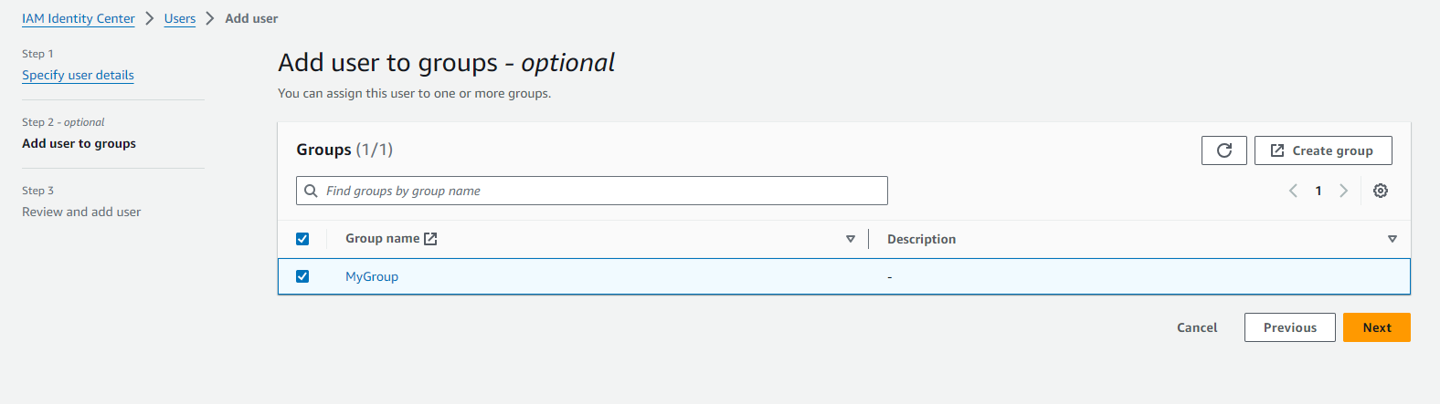
11. 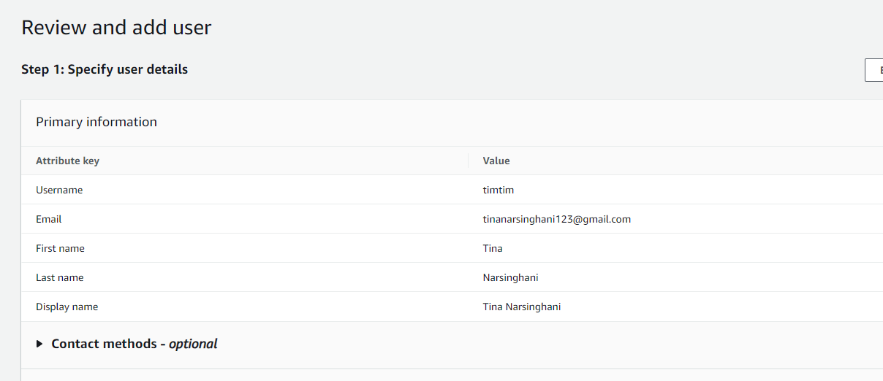
12. Copy the password and all instructions  
    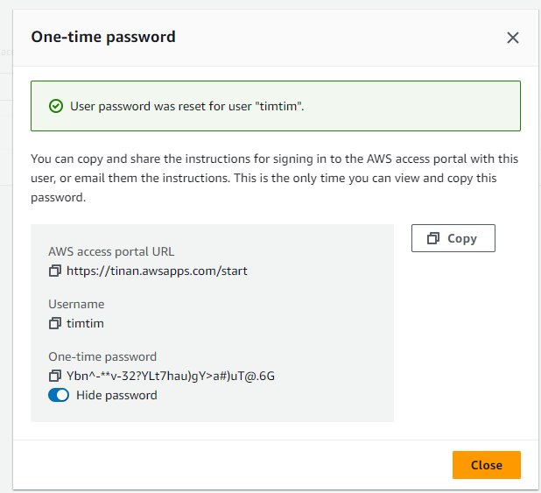
13. 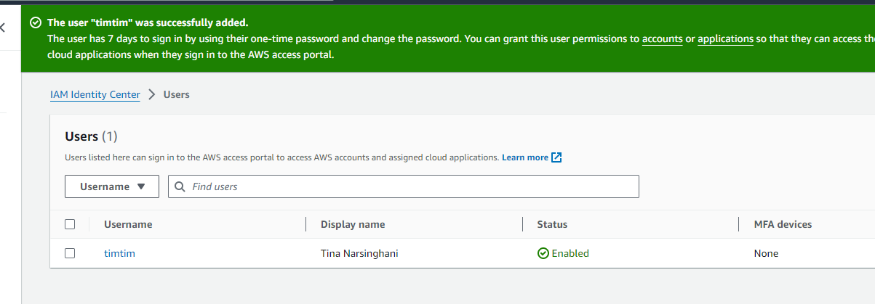
14. Go to permission sets  
    Create permission sets  
    Default permissions  
    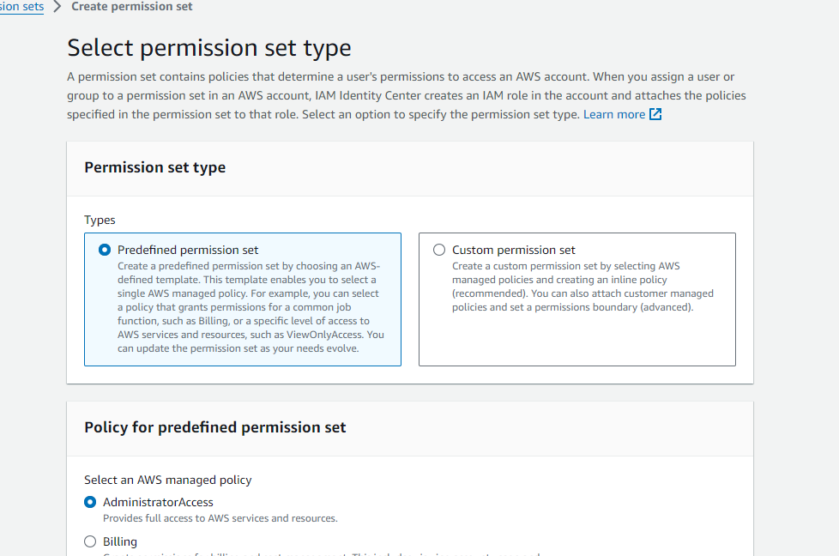  
      
    Everything will be default and then create
15. Go to Groups  
    Go to your group (My group in this case)
16. Go to the custom url created and sign in
17. 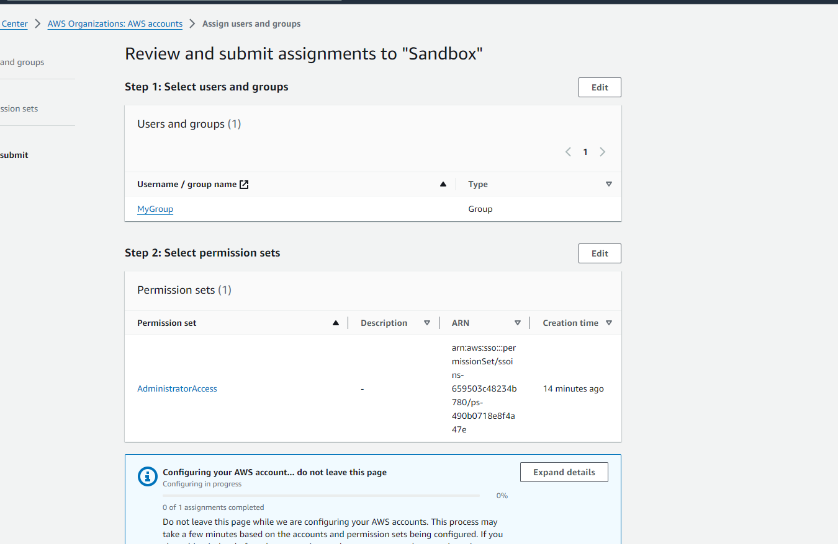
18. Next Next and Submit
19. After creating and enabling Single sign on, login again to check.